Regular polygon area:

https://www.edu.xunta.es/espazoAbalar/sites/espazoAbalar/files/datos/1491480499/contido/ud10_trigonometria_I/imagen_formula_area_poligono.gif

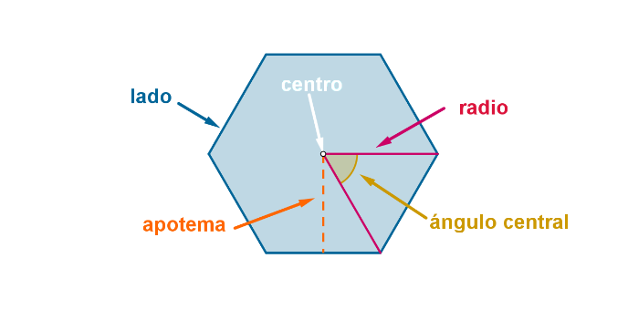

Get Regular polygon Area l, n : A

1. Get lado l
2. Get number of sides n
3. Get central angle $$α= \frac{360°}{Number of sides}$$
4. Get apotema l, $α$: ap $$ap= \frac{side}{2\tan{\frac{α}{2}}}$$
5. Get perimeter l, n : p $$perimeter= side*Number of sides$$
6. Get area p, ap : A
7. Mostrar A